3.1 Organization of the Nervous System

* **Peripheral nervous system**: carry information to and from the CNS, 31 pairs of spinal nerves, 12 pairs of cranial nerves
  + **Afferent** (sensory) division carries information to the CNS
  + **Efferent** (motor) division carries information from the CNS to **effector organs**
    - **Somatic nervous system**: voluntary (skeletal muscles)
    - **Autonomic nervous system**: involuntary, controls homeostasis (smooth muscle, cardiac muscle, and glands)
      * **Sympathetic nervous system**: fight or flight response, increases heart & breathing rate, decreases intestinal activity & urination
      * **Parasympathetic nervous system**: opposite of sympathetic
* **Central nervous system**: process information
  + **Brain**: maintain homeostasis; has over 100 billion neurons
  + **Spinal cord**: link between brain and PNS; reflex center
* 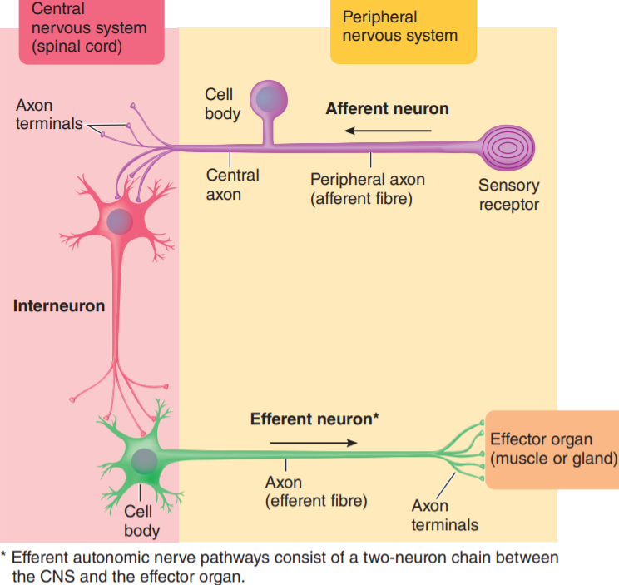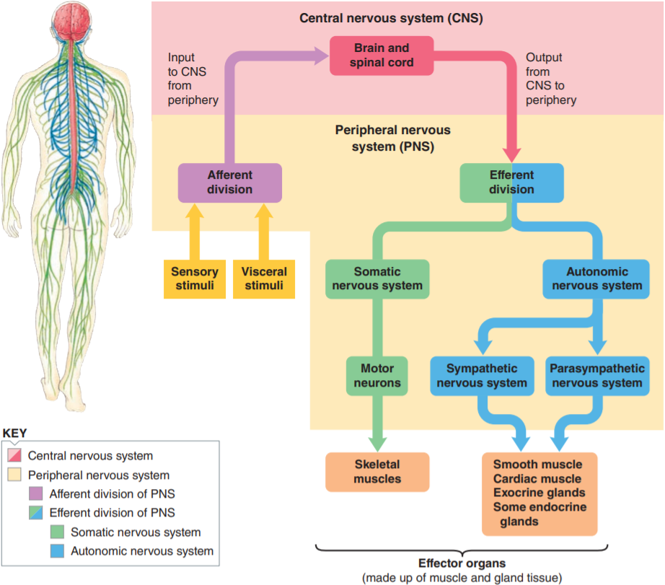Three types of neurons: **afferent neurons**, **efferent neurons**, and **interneurons** (99% of our neurons are interneurons within the CNS)

3.2 Central Nervous System

* **Brain stem**: oldest in evolution, vegetative functions (unconscious, essential for life)
* **Cerebellum**: coordination and balance
* **Forebrain**
  + **Diencephalon**
    - **Hypothalamus**: homeostasis
    - **Thalamus**: sensation
  + **Cerebrum**: more convoluted in advanced vertebrates, 80% brain weight
    - 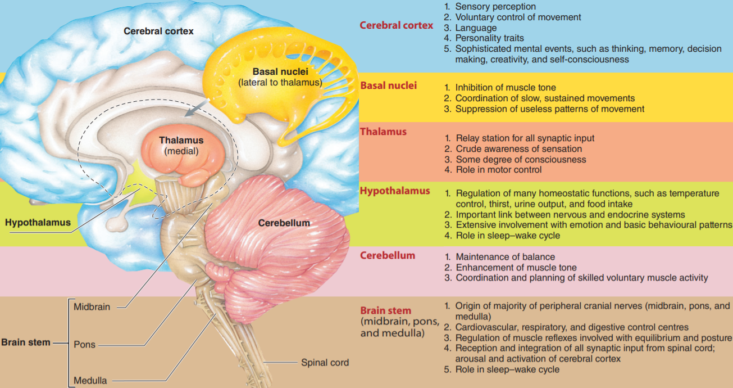**Basal ganglia**: motor control, coordination
    - **Cerebral cortex**: most complex part, many functions including thinking

3.3 Protection for CNS

* **Glial cells** (neuroglia): ~90% of the cells within the CNS, supports the neurons
  + **Astrocytes**: most abundant, many functions
    - Physical support
    - Scaffold during fetal brain development
    - Induce formation of blood–brain barrier
    - Form neural scar tissue
    - Take up and degrade released neurotransmitters
    - Take up excess K to help maintain proper ion concentration
    - Enhance synapse formation and strengthen synaptic transmission
  + **Oligodendrocytes**: Form myelin sheaths in CNS
  + **Microglia**: Defence for brain (phagocytic scavengers)
  + **Ependymal**: Line internal cavities; form cerebrospinal fluid; neural stem cell
* Four protection mechanisms
  + **Bony enclosure**: skull and vertebral column
  + **Meninges**: 3 protective & nourishing membranes
    - **Dura mater**: tough, inelastic; 2 layers, contains dural / venous sinuses (Brian fluids) in between to be returned to the blood stream
    - **Arachnoid mater**: cobweb appearance; protrusions of arachnoid tissue (**arachnoid villi**) penetrate into the dural sinuses
    - 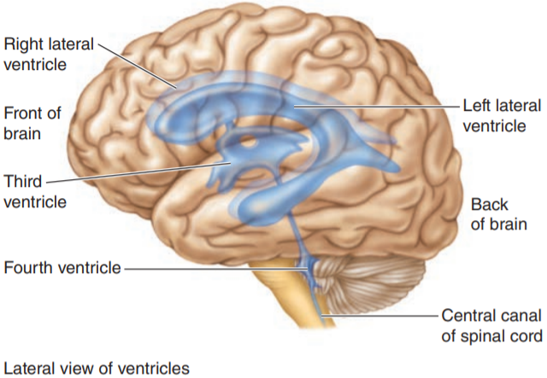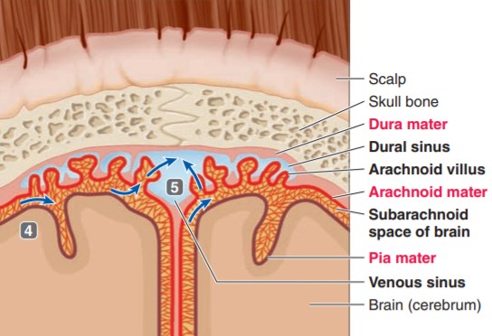**Pia mater**: innermost, fragile, can go deep into the brain to provide blood
  + **Cerebrospinal fluid** (CSF): between arachnoid and pia (subarachnoid space)
    - Same density as brain, shock absorbing
    - Affects composition of **brain interstitial fluid** (direct contact neurons)
    - Formed in **choroid plexuses** (masses of pia mater tissue that dip into pockets formed by ependymal cells), after formation, CSP
      * Flows through the four interconnected ventricles
      * Enters the subarachnoid space from the fourth ventricle
      * Flows between the meningeal layers over the entire surface of CNS
      * At upper regions of the brain, reabsorbed from the subarachnoid space into the venous blood through the arachnoid villi
  + **Blood–brain barrier** (BBB): special capillary structures limit exchange between the blood and brain interstitial fluid
    - **Anatomic**: In brain capillaries cells are joined by tight junctions so nothing can be exchanged by passing between the cells
    - **Physiological**: since exchange can only happen through the cells, ions / big molecules cannot go through without carrier channels

3.4 Spinal Cord

* Spinal cord structure: spinal nerve protected by vertebral column
  + 8 pairs of **cervical** (neck, namely C1–C8), 12 **thoracic** (chest), 5 **lumbar** (abdominal), 5 **sacral** (pelvic), and 1 **coccygeal** (tailbone) nerve
  + Spinal cord extends only to first / second lumbar, remaining nerves (thick bundle of elongated nerve roots) are called the **cauda equina** (horse’s tail)
  + **Grey matter**: primarily cell bodies & dendrites, short interneurons, and glial cells
    - Dorsal (posterior) horn: cell bodies of interneurons
    - Ventral (anterior) horn: cell bodies of efferent (motor) neurons
    - Lateral horn: nerves supply cardiac, smooth muscle and exocrine glands
  + **White matter**: long interneurons axons organized tracts of similar functions, myelinated (grey is unmyelinated)
    - Nerves**:** bundles of axons
    - Tracts**:** bundles of neurons
    - **Ascending tract**: up, carry info to brain, terminates at cerebellum
    - **Descending tract:** down, carry info down to skeletal muscles
  + Diagram

    Description automatically generatedDorsal root (afferent) & ventral root (efferent) & **dorsal root ganglion** (collection of neuronal cell bodies located outside the CNS)
* **Reflex**: activity between afferent input and efferent output without involving the brain
  + **Simple** **reflexes** (basic, instinct) vs **acquired reflexes** (conditioned, learned)
  + **Reflex arc**:
    - **Receptor**: responds to a **stimulus**
    - Afferent pathway: relayed to integrating centre
    - **Integrating centre**: CNS, spinal cord and brain stem integrate basic reflexes, higher brain levels process acquired reflexes
    - **Efferent pathway**: transmit instructions to effector
    - **Effector**: carry out responses
  + Types of reflexes:
    - **Stretch reflex**: **monosynaptic**, stretch-detecting receptor directly connector to effector to counter the stretch (contract the same muscle)
      * Knee jerk, essential for standing straight under gravity
    - **Withdrawal reflex**: polysynaptic, spinal reflex (all transmissions done in spinal cord), can be overridden voluntarily, 3 parts (Ex. Hand on fire)
      * Contract muscle to withdraw hand
      * **Reciprocal innervation**: relaxes opposite muscle
      * Notify the brain
    - Golgi tendon reflex: prevents over-contraction, kind of opposite to stretch but polysynaptic
    - Crossed extensor reflex: controls opposite side of body couple with withdraw reflex for posture / balance

3.5 Brain Stem

* 3 regions: **Midbrain**, **pons**, and **medulla**
* 5 functions:
  + Majority of the 12 pairs of **cranial nerves** arise from the brain stem except vagus (major nerve of the parasympathetic nervous system)
  + **Neuronal clusters** (centres) control heart, blood vessel, respiration, and digestion
  + Muscle reflexes involved in **equilibrium and posture**
  + **Reticular formation** (widespread network of interconnected neurons): ascending fibres (**reticular activating system** (RAS)) carry signals upward to arouse and activate the cerebral cortex and controls **alertness / attention**
  + 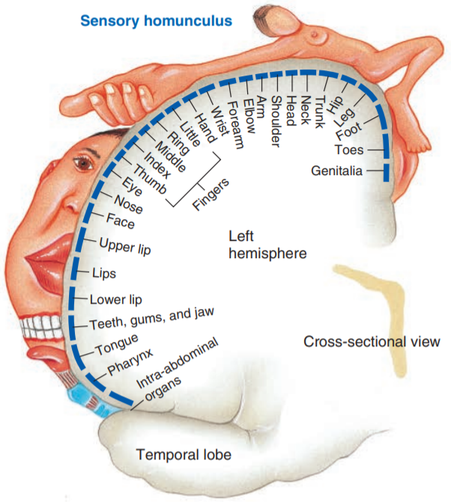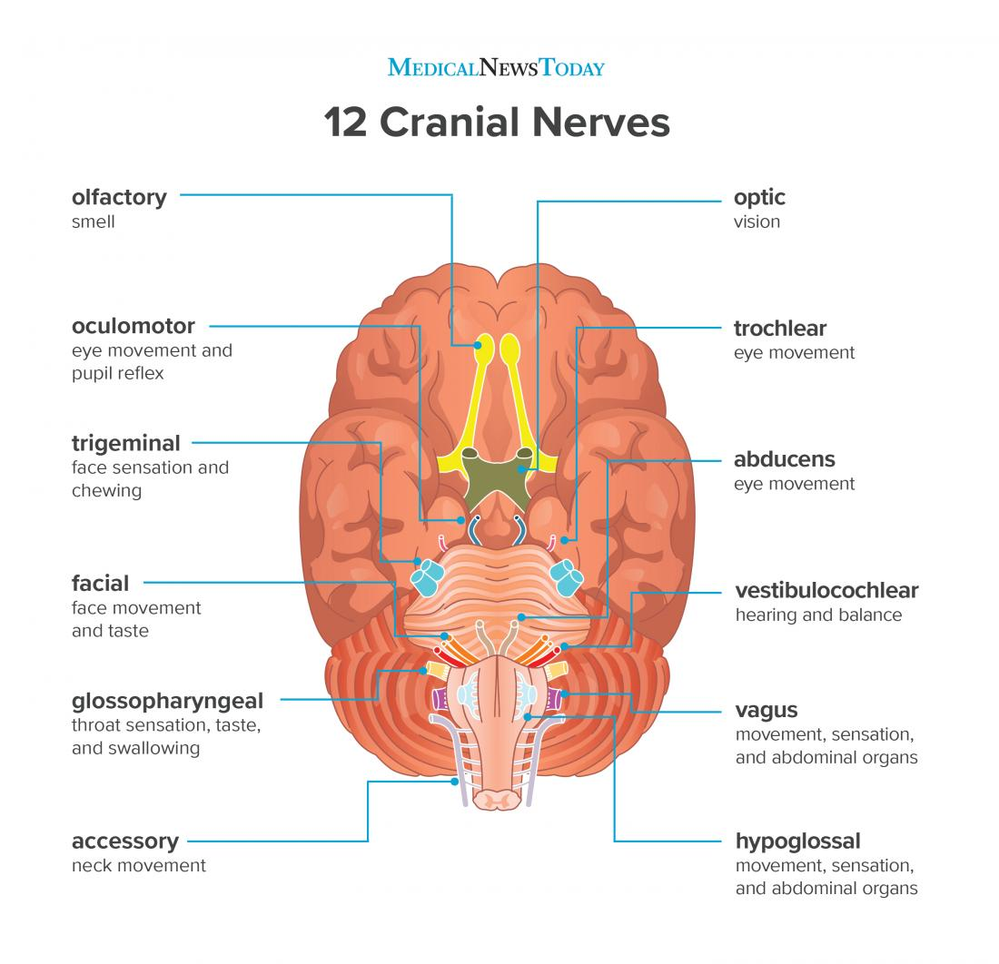**Sleep** traditionally have been considered to be controlled by brain stem, although recent evidence suggests that slow wave sleep is controlled by hypothalamus

3.7 Cerebral Cortex

* Right and left cerebral hemispheres connected by **corpus callosum** (thick band consisting of ~300 million neuronal axons travelling between the two hemispheres)
* Brain **plasticity**

4.1-4.3 Peripheral Nervous System: Afferent Division

* **Visceral afferent**: from internal organs, mostly subconscious except pain
* **Sensory afferent**: from body surface / muscles / joints, mostly conscious
  + 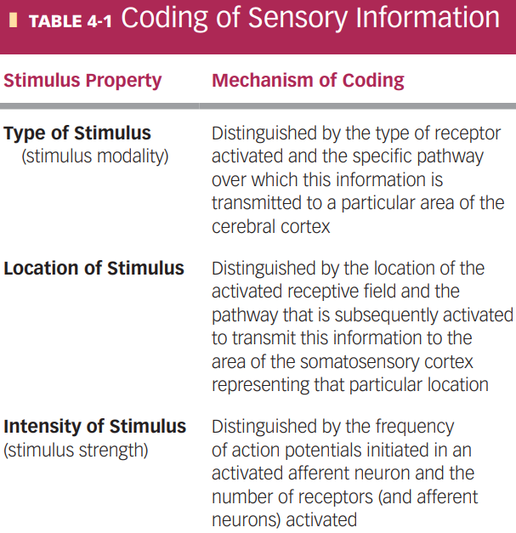**Somatic senses** (body senses, physical) vs **special senses** (vision, hearing, taste, smell, and equilibrium)
* **Sensory receptors** (4 primary types): **thermoreceptors** (heat), **mechanoreceptors** (pressure), **photoreceptors** (light), and **chemoreceptors** (chemicals)
  + **Nociceptors**: only senses pain
  + Receptors can be **specialized ending** of the afferent neuron (stimuli directly triggers Na channels), or a **separate receptor cell** closely associated with the dendrite of the afferent neuron (cell release chemicals like synapse)
    - Both produces graded potential: **generator potential** (if specialized ending) or **receptor potential** (if separate cell)
* **Transduction**: conversion of stimuli to electrical signal (all stimuli are eventually action potentials of the neurons)
  + Distinguish signals through **MILD** (**modality**, **intensity**, **location**, **duration**)
  + **Adequate stimulus**: type of stimuli the receptor responds best to, can respond to other stimuli (create similar respond since **modality of receptor** is the same)
  + Intensity cam be both frequency and number of receptors activated
* **Tonic Adaptation** decrease intensity when stimuli continuously present
  + **Tonic receptors**: do not / mildly adapt (muscle, joints, need continuous signals)
  + 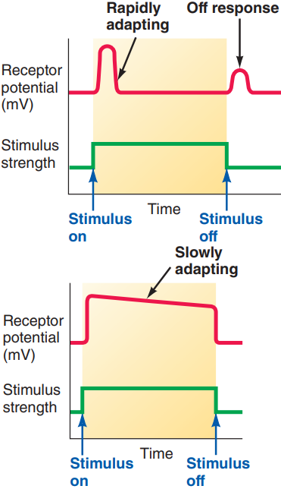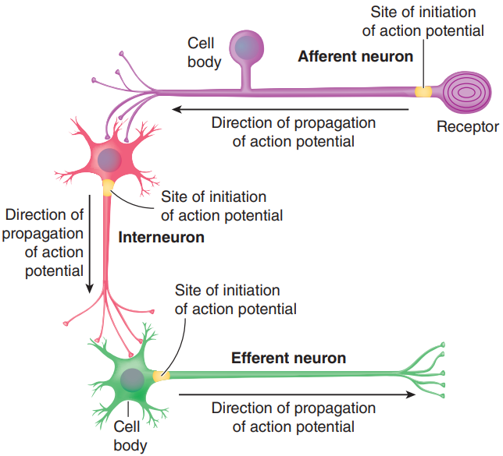**Phasic receptors**: rapidly adapt, respond to change in stimuli (tactile)
* **labelled lines**: chains of neurons in the somatosensory pathway, accomplish progressively more sophisticated processing of the sensory information
  + first-order, second-order, third-order sensory neurons
* **Receptive field**: responsive region, size varies inversely with concentration receptors, smaller field = higher acuity / discriminative ability
* **Lateral inhibition**: inhibitory interneurons between parallel sensory neurons, stronger stimuli inhibit weaker stimuli around it for sharper / finer sensations (touch & vision)
* Tactile mechanoreceptors (5 types):
  + **Pacinian corpuscles**:phasic; heavy touch, rough surface, vibration (250Hz)
  + **Meissner’s corpuscles**: phasic; light touch, vibration (>50 Hz)
  + **Merkel’s discs**:tonic; vibration (5-15 Hz)
  + **Ruffini corpuscles: tonic**; stretch and torque in deep layers of skin
  + **free nerve endings** (most abundant, around hair roots / eyes / other tissues, specialize in touch and pressure, also used for temperature and pain)

4.8-4.10 Peripheral Nervous System: Efferent Division

* **Acetylcholine** & **norepinephrine**: only two neurotransmitters used by effector neurons
* **Automatic nervous system** (ANS): controls smooth muscles, glands, heart, and gastrointestinal tract; controlled by hypothalamus, brain stem, and spinal cord
  + Autonomic nerve pathways: always a **two-neuron chain**, axon of first neuron (**preganglionic fibre)** synapse with second neuron in a ganglion (neurons outside CNS), axon of second neuron (**postganglionic fibre**) connects with effector organ
  + Postganglionic fibres end in **varicosities**, (numerous swellings / synaptic knobs), release neurotransmitter over a large area (innervate organs rather than cells)
  + 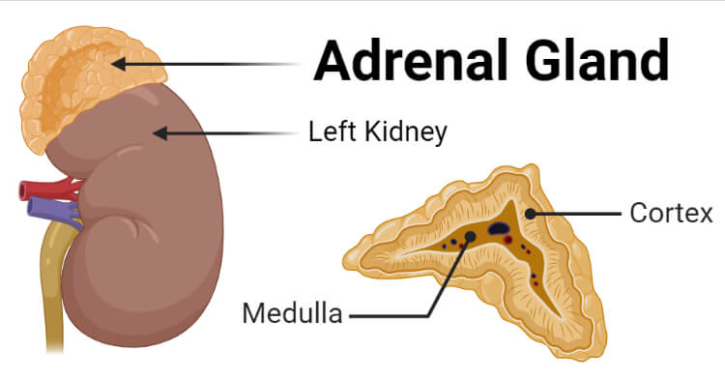**Adrenal medulla**: modified sympathetic ganglion that does not give rise to postganglionic fibres, releases 2:8 norepinephrine and **epinephrine (adrenaline)**
  + **Antagonistic** (stopping one and activating the other, faster, most organs use this) vs **tonic** (control with only one, blood vessels & sweat glands only sympathetic)
  + **Agonists** (bind to same receptor to mimic transmitter) vs **antagonists** (bind to same receptor to block transmitter) drugs
  + CNS control:
    - Spinal cord: autonomic reflexes (urination, defecation, erection), subject to control by higher levels of consciousness
    - Medulla: most directly responsible for autonomic output, centre for controlling cardiovascular, respiratory, and digestive activities
    - Hypothalamus: integrates the autonomic, somatic, and endocrine responses accompanying emotional and behavioural states.
    - 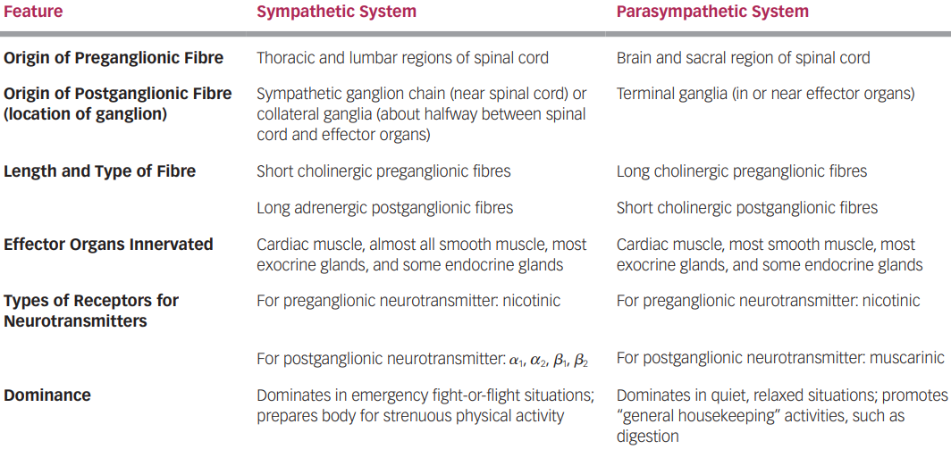Prefrontal cortex: emotional expression of the individual’s personality (?)

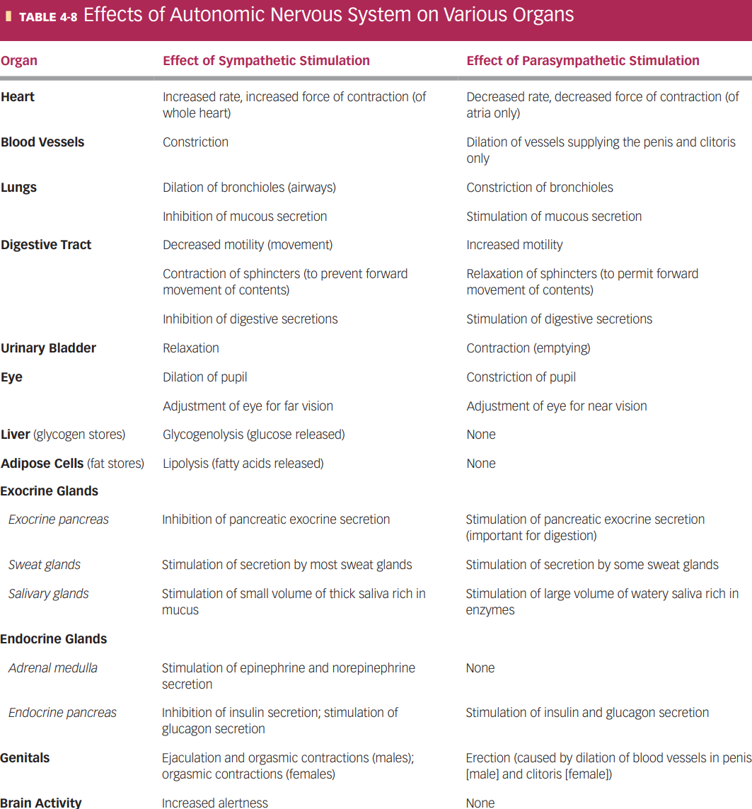

* + Neurotransmitter receptors:
    - Acetylcholine (**cholinergic**) receptors:
      * **Nicotinic**: found on the postganglionic cell bodies in all autonomic ganglia, depolarizes in respond to acetylcholine
      * **Muscarinic**: found on effector cell membranes, respond to acetylcholine released from parasympathetic fibres only
    - 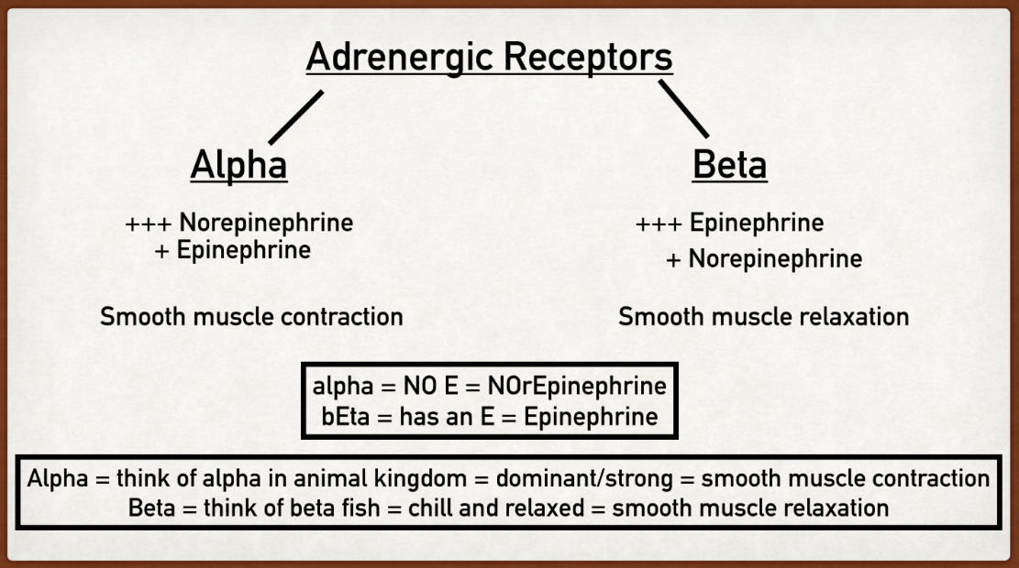**Adrenergic** (catecholamine) receptors: respond to epinephrine and norepinephrine; transfer signal into the cytoplasm, influence metabolic processes and cellular function; $α_{1}$, $α_{2}$, $β_{1}$, $β_{2}$, $β_{3}$ types
* **Somatic nervous system**: motor neurons and skeletal muscle
  + **Motor neurons**:
    - cell bodies in ventral horn (for muscles in head are in brain stem),
    - axon continuous from CNS to end (skeletal muscle)
    - releases acetylcholine – excitation and contraction of muscles
    - can only stimulate muscles but not inhibit
  + **Final common pathway**: only way other parts of the nervous system influence skeletal muscle is by acting on motor neurons
  + 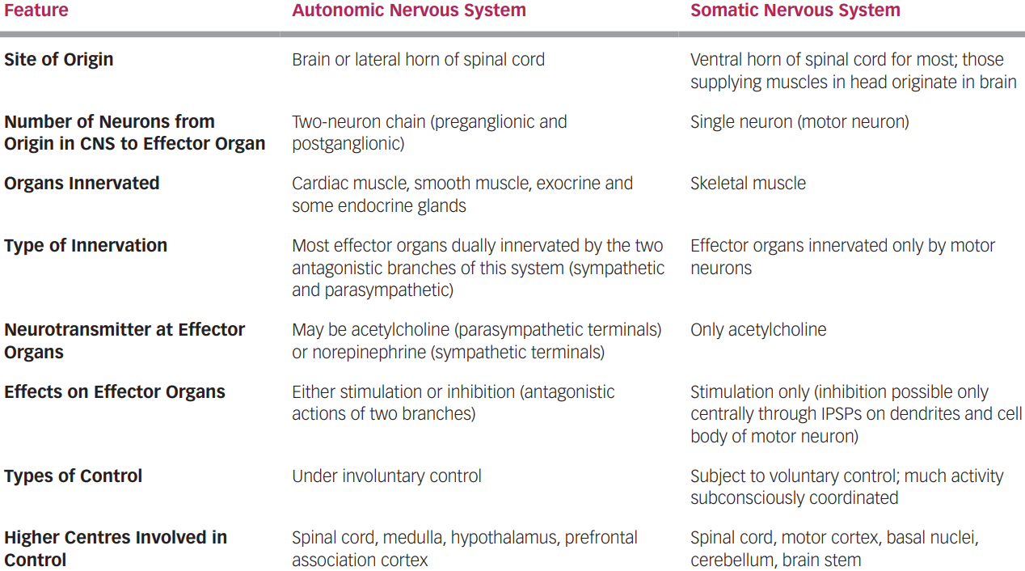**Voluntary** but involves subconscious processes (balance and coordination)